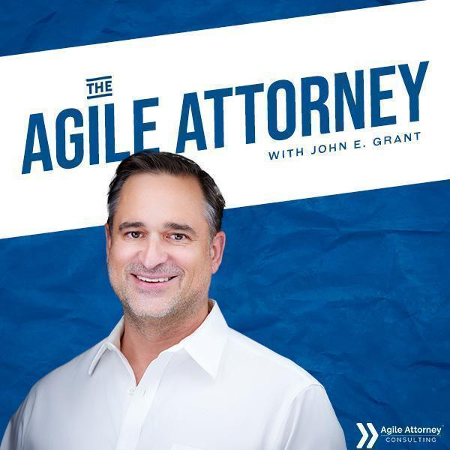

Full Episode Transcript

With Your Host
John E. Grant

Hey everyone. I'm out spending time with family at a youth sports tournament this week, so this is going to be a relatively short episode, but I think it's a practical one with a simple but powerful tip that will help you improve the quality of deliverables as they flow through your law practice. And that, in turn, will help improve the efficiency of your work overall.
You're listening to the Agile Attorney Podcast, powered by Agile Attorney Consulting and Greenline Legal. I'm John Grant and it is my mission to help legal practitioners of all kinds build practices that are profitable, sustainable, and scalable for themselves and the communities they serve. Ready to become a more Agile Attorney? Let's go.
So, here's a concrete and relatively quick tip this week, but it's one that has come up several times in my work with clients, and I think it's worth calling out for all of you as well. When you're writing policies and procedures, I urge you not to think of them as recipes or instruction sets, so much as you think of them as quality standards. And yes, it's important to give some overall direction, but a good policy sets your team members up to engage with the work on a deeper level instead of just turning off their brains and following instructions.
I did a deep dive on this back in episode 22, How to Write Effective Law Firm Policies, if you want to refresh on that topic. But one of the key things that I didn't necessarily talk about in that episode comes from how you frame your checklists. Now, most people's natural tendency is to set them up as to-do lists. "Insert tab A into slot B" type of stuff. But not only is that not the most engaging way to phrase things, checking those types of things off turns out to be a little bit ambiguous.
So, I want to encourage you instead to change your phrasing so that rather than creating to-do lists, your quality standards are written as "done lists" instead. And that means writing them in the past tense. So, when you see a checkmark next to them, you can be 100% confident that it was completed.
So, let me unpack what I mean by that. And you've heard me talk before about the most powerful quality standards when your firm is in the early phases of process improvement work. And there's two of them.
Number one is the definition of done. What are all of the things that need to be true or at least accounted for before we consider this work or this deliverable to be complete to the quality standard that we've established? And the whole point here is to avoid the frustration of having work come back to you or having to send it back to someone else because it didn't meet some standard of work or quality that should have been clear from the beginning.
The other one of these standards is the definition of ready. What are all the things that need to be true or at least accounted for before we should even begin work on this particular set of tasks or deliverables?
And this one prevents you from starting work too early, before you have all the information or tools that you need to do the job correctly, and then having to backtrack and redo things because you or someone on your team made assumptions that turned out to be wrong because you jumped the gun.
This is the stage-gate that makes sure we've got, again, all the ingredients and tools necessary to sit down and do the work in a single sitting without having to go back to the client for more information or to a senior attorney for more direction. We want that work to really flow quickly through the process once everything is ready, right? We don't want to have to stop it partway through and then go back and finish it later.
And I sometimes talk about this in the context of cooking a recipe. You don't want to get your batter halfway mixed only to realize you need to go to the store to get more eggs.
The other problem when you stop work partway is that it's easy to lose track of what's done and what's not done. And I don't think I've used this analogy on the podcast before, but I say it sometimes around my house. There's nothing more problematic in the kitchen than a half-empty dishwasher.
Now, I've got two kids, and I made the mistake when they were little of divvying up the chore of emptying the dishwasher into two parts: the top rack and the bottom rack. But what would wind up happening is one kid would empty their half and the other kid would not. And then someone would look into the dishwasher, maybe me, assume the things in it were dirty because it was only part full, and then add more dirty dishes to it. And especially if that bottom rack was clean and you add a dirty glass to the top rack, well, now the bottom rack isn't clean anymore.
So, I have a rule, right? It's not always followed still, but it's a good rule. Empty the whole dang dishwasher in a single swoop. It doesn't take that much more time, and it avoids a whole lot of potential problems. And I want you to have that same type of rule in as many deliverables in your law practice as possible.
But getting back to using a done list instead of a to-do list, this past tense phrasing hack turns out to be pretty powerful. So instead of having a task that says, "Conduct conflict check," which is what you do for a to-do list, I want that checklist item to say, "Conflict check complete." And what I like about it is that it's really clear what the status is. If there's a checkmark next to it, it is unambiguously done. We've looked at it, we have completed it to the standard of quality that we've established for conflict checks in this firm, and it is done-done.
To give you a few more examples, right? I don't want to see a task list item that says, "Draft pleadings," I want to see one that says, "Pleadings drafted." I don't want to see one that says, "Serve complaint on defendant," I want to see one or more tasks that say things like, "Pleadings package sent to process server." "Service confirmation received." "Service confirmation e-filed with court." Things like that.
Again, it makes things really clear what is done, but also what the next actionable step is and where things are in the overall workflow. And as a manager, as a process person, I really like to be able to look at a checklist, and my clients really like this too, and be really clear that all of these things are what I will call done-done. My brain doesn't have to worry about them anymore. And then I can use that information to say, yes, this is now actually ready for the next stage of work.
I also find that the people doing the work like these done lists better too. And there's always something satisfying about checking off a checklist item, but I think the definitive language of the past tense in a done list is especially fulfilling.
Now, let's talk a minute about how to implement this approach. And I will readily admit that going into the past tense is not how most of our brains work when we're spitting out or writing down processes and procedures off the top of our heads. So, getting to this improved state, this past tense way of phrasing definitions of ready, definitions of done, and frankly, any other checklist that you have as part of your policies and procedures, I think it can be helpful to do it in two stages.
Number one is just do the brain dump. Don't try to write in the past tense if that's not naturally how your brain wants to address it. Just get the information out onto a page. Then you can go back through it with an editing round and convert those things to past tense, or, and I've been a little critical of AI lately, but this is one of those things that's really easy to dump into an AI tool and have it convert all the things you just wrote down into the past tense so that you can use them for these quality standards, these done lists.
Also, this is not to say that there's not a place for these instruction-oriented checklists at times, especially when you're training new people, bringing folks up to speed. Sometimes it makes sense to just say, "Set the oven to 350," and, "Find a medium bowl, mix the dry ingredients," whatever the right instruction happens to be. But I think that should be the minority.
When you're talking about developing your processes and really making sure that you have the right quality checks, and this is both for the people doing the work and also for the people who are doing the review on the work, engaging in that quality assurance phase, I think phrasing your task lists, your deliverables, your commitments in the past tense is the best way to efficiently and effectively communicate those things that are done, all the way done, as opposed to the things that you intend to do when you're picking up a particular piece of work.
All right, I'm going to leave it there for now. This is a very quick episode. It might be my shortest one yet, but I'm out having a summer, which I talked about just a few episodes ago. If you have any thoughts or questions or feedback, please don't hesitate to reach out to me at john.grant@agileattorney.com.
As always, this podcast gets production support from the fantastic team at Digital Freedom Productions, and our theme music is "Hello" by Lunara. Thanks for listening, and I will catch you next week.

